BPCI Advanced Model Monitoring & Compliance

# Media, Social Media and Watchdog Monitoring & Analysis

This could be a value-adding service we perform for the BPCI Advanced model team, especially as an “early warning” system for potential issues, challenges, and topics of discussion as identified by stakeholders.

**Stakeholders** here is anyone with an interest in the Model, especially those who are part of media and social media discussions about it. This could include Participants themselves, industry groups, beneficiary advocacy groups, CMS-watchers, vendors, academic publications, health and health insurance blogs, and others.

Net impact on project resources should be close to zero, as we can repurpose some of IMPAQ’s planned time that would have supported Virtual Site Visits.

Primary activities include:

* Monitor coverage and mentions of the BPCI Advanced Model, and its Participants, across a variety of platforms, to find **emerging issues** (using Topic Mining) and to identify relevant trends in **sentiment** (using Sentiment Analysis).
* Capture lessons learned, best practices, and challenges or barriers around implementation of the BPCI Advanced model, unintended consequences, and maintaining compliance with Model requirements.

The process will be human-driven and iterative, but will use AI/machine learning to comb through media sources and filter for relevant information. In later model years it won’t require the same level of setup, so costs will be minimal other than reviewing and reporting results and tweaking the algorithm.

Note: If additional monitoring for complaints and allegations is needed beyond Participant self-report, targeted PECOS reviews, and CPI’s activities, then setting up ongoing monitoring at the level of individual Participants would be a good way to pick up any provider- or Participant-level issues that are reported publicly.

# Media Analysis

Automatic measures of media reaction and analysis of coverage content:

* Highlights of coverage – positive/negative reactions, concerns raised. Uses “Automatic Text Summarization” to:
  + Reduce long documents into much shorter documents
  + Remove up to 90% of unnecessary text
  + Automatically produce keyword lists of important concepts
* Volume/intensity of media reaction to Model announcements
  + Number of articles covering a given topic or event
  + Volume and source of comments on articles as well as overlap/evidence of coordinated commenting campaigns
  + Use incidence and arrival rate to understand mainstream media and alternative media interest
* “Media” can include industry bulletins, trade publications, blogs, newsletters, and digests.
  + E.g. larger outlets such as Modern Healthcare and Medscape, but can identify individual reporters/bloggers as well. [1]
  + Includes both health-oriented outlets as well as other interests such as articles by law firms and lobbying groups (e.g. Ropes & Gray, Baker Donelson)
  + Worth monitoring “watchdog” sites like Pro Publica, which monitors (among other things) patient safety reports and payments from pharma companies to docs and other providers, and advocacy sites like AARP and Center for Medicare Advocacy
* Peer-reviewed literature may come up, but with less frequency, in journals such as JAMA

# Social Media Analysis

Similar to media analysis, but on social media platforms.

## Twitter analysis:

* Timing and “reaction speed” to BPCI Advanced-related announcements from CMMI
* Level and variety of engagement with CMMI tweets and announcements:
* Geographic analysis in heat-maps or other visual representations:
* Content analysis (positive/negative, keywords, word cloud)
  + Many Twitter mentions are sales pitches from vendors or conveners such as Archway Health and NaviHealth. May be useful to know who is in the space, and what problems they’re highlighting as something they can solve.
  + These Tweets also point to other activity and discussion (e.g. conference presentations, webinars, appearances on other blogs and podcasts).

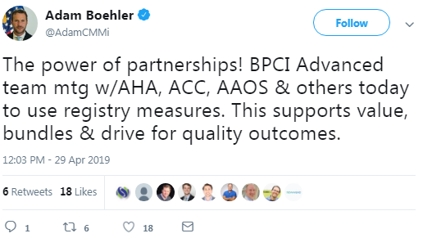

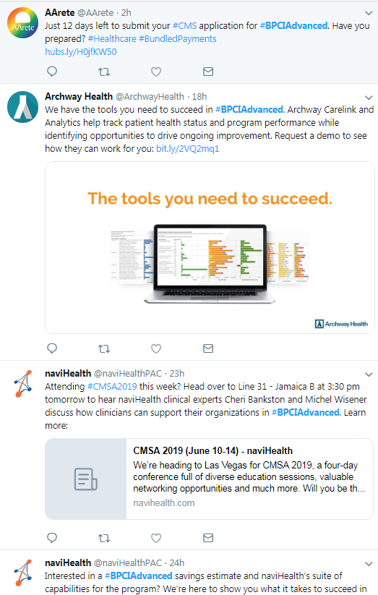

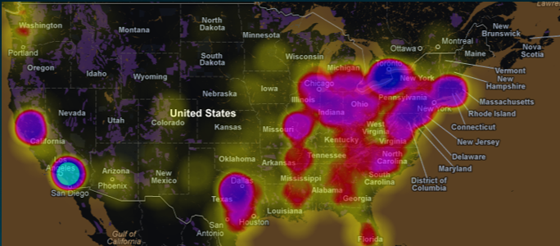

## Google trend analysis:

* Frequency, patterns and timing of pre-determined phrases
  + Phrases to be developed based on:
    - CMMI announcements
    - Model keywords
    - New phrases arising from media/social media.
* Peaks in trends are candidates for Twitter analysis as well. For example, this trend analysis of the search term “Medicare Part B drug”:

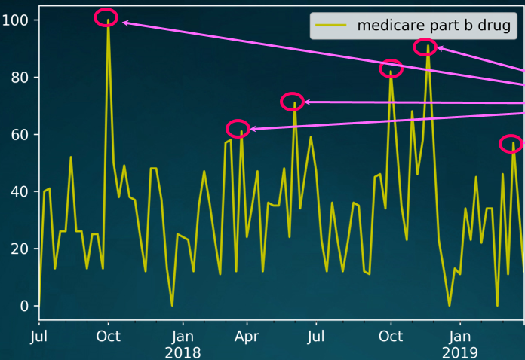

## Other Potential Sources (Non-Social Media)

* Leapfrog Group hospital performance and public safety scores

## Reporting Frequency and Methods

* Weekly or monthly summaries and highlights of important trends, depending on when events and milestones occur
* Visualizations provided when helpful; reports can be customized for sharing with front office or other stakeholders

1. Two examples of Modern Healthcare coverage of the model are: “BPCI Advanced participation dips 16% in first five months”(March 21, 2019) and “Providers blame unpredictability for slow adoption of CMS’ risk-based models” (March 30, 2019). An example of Medscape coverage is an article referencing a journal article that appeared in JAMA Cardiology: “Factors Associated With Participation in Cardiac Episode Payments Included in Medicare’s Bundled Payments for Care Improvement Initiative” (August 2018).